WEEK 5

Performance Optimization and
Interactive Feature Enhancement
Tableau Data Analytics Internship
HR Employee Attrition Dashboard — Strategic Performance & UX Plan
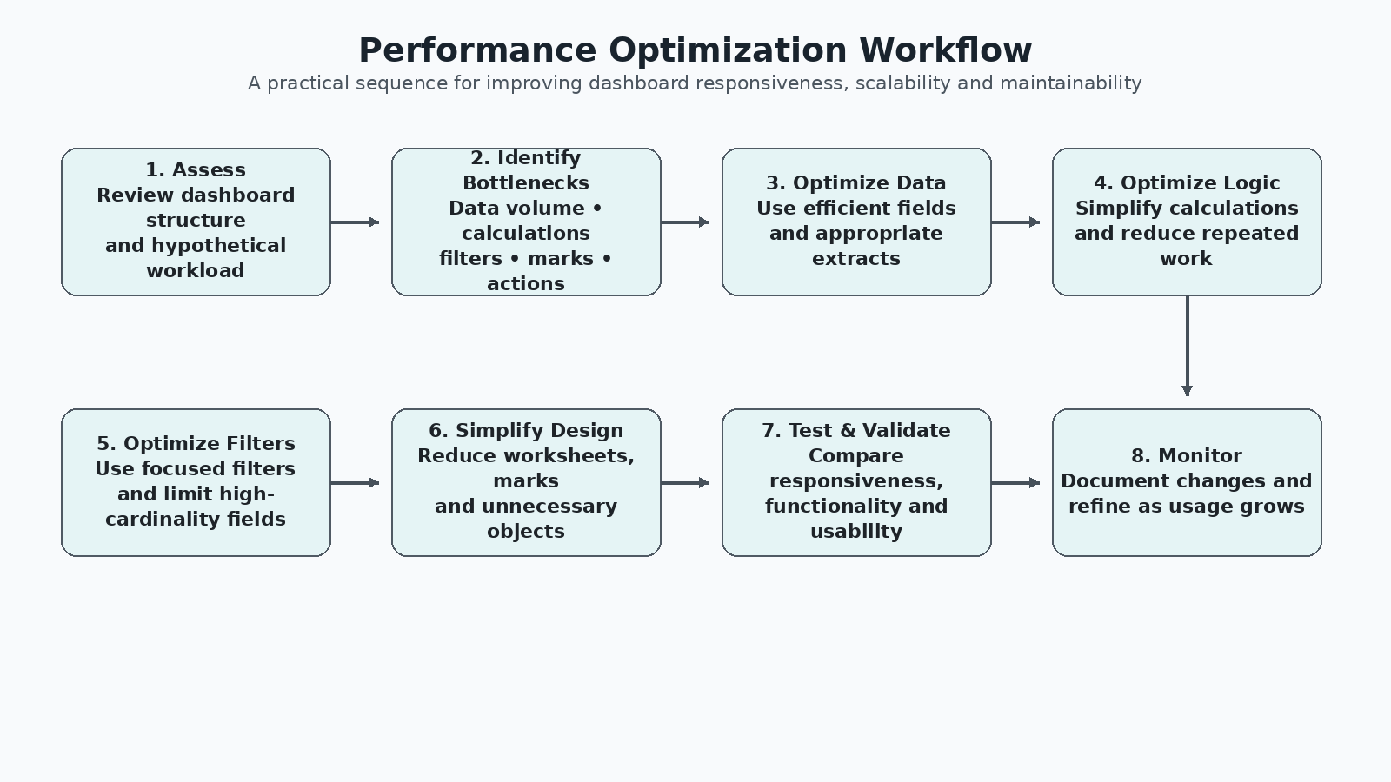

1. Executive Summary
Week 5 focuses on improving a Tableau dashboard so that it remains responsive, scalable, maintainable and easy to use as users interact with it. The work continues the HR Employee Attrition context used in Week 4, where advanced Tableau techniques included a heat map, dual-axis visualization, box plot and calculated-field analysis.
This report treats the dashboard assessment as a hypothetical performance review, as required by the assignment. No actual load-time benchmark has been claimed because no controlled performance test or measured timing results were supplied. Instead, the report identifies likely bottlenecks and translates Tableau-oriented best practices into a practical optimization plan.
The second major focus is interactive feature enhancement. Dynamic filters, drill-down navigation, parameter controls, dashboard actions and focused tooltips are proposed so users can explore the data without making the dashboard visually crowded.

2. Week 5 Task Objective
The objective is to optimize dashboard designs for performance, scalability and enhanced interactivity, while documenting methods for streamlining data processing and improving dashboard response times. The assignment also requires intuitive interactive components, clear implementation steps, expected outcomes and a strategic guide that can support future Tableau development.
Requirement | Week 5 Response
Performance optimization | Identify likely bottlenecks and propose practical data, calculation, filter and design optimizations.
Scalability | Reduce unnecessary workload so the design can handle future growth more efficiently.
Interactivity | Introduce dynamic filters, drill-downs, parameters, actions and focused tooltips.
Documentation | Provide an organized strategy, implementation roadmap, diagrams and expected outcomes.
User engagement | Make exploration purposeful and reduce visual clutter and unnecessary interaction steps.

3. Dashboard Context
The working analytical context is the HR Employee Attrition dataset used in Week 4. It contains 1,470 employee records and fields such as Attrition, Department, Job Role, Monthly Income, Job Level, OverTime, Job Satisfaction, Performance Rating, YearsAtCompany and Employee Number.
Week 4 established the analytical foundation with advanced views including Employee Attrition Rate by Department and Job Role, Income vs Attrition by Job Level, Income Distribution by Job Role, and an Income Band calculated field. Week 5 extends this foundation by concentrating on dashboard performance and interaction quality rather than adding a large number of new charts.

4. Hypothetical Performance Assessment
Because the Week 5 assignment explicitly asks for assessment of a hypothetical dashboard design, the following issues are treated as potential bottlenecks to investigate. They are not presented as measured defects in the user's Tableau workbook.
Potential Area | Possible Bottleneck | Why It Matters
Data source | Unnecessary fields, rows or duplicated data | More data can increase processing and extract/query workload.
Calculated fields | Complex or repeated row-level logic | Calculations may add processing effort when views are rendered.
Filters | Too many filters or high-cardinality filters | Each filter can increase query work and make the interface harder to use.
Dashboard structure | Too many worksheets and objects | More sheets can require more queries and increase rendering complexity.
Marks | Dense charts with excessive marks | Rendering many marks can slow visual response and reduce readability.
Actions | Too many simultaneous actions | Complex interaction chains can make behavior harder to predict and test.
Design | Redundant charts or decorative elements | Unnecessary visual objects consume space and may add workload without analytical value.

5. Performance Optimization Strategy
The optimization strategy follows a sequence: assess → identify → optimize data → optimize calculations → optimize filters → simplify the dashboard → test → monitor.

5.1 Data Processing Optimization
- Keep only fields required for the analytical questions and dashboard interactions.
- Remove unused columns, duplicated fields and unnecessary intermediate calculations where they do not contribute to the final experience.
- Use appropriate aggregation levels so the dashboard does not process more detail than the visual actually needs.
- Where appropriate, use a Tableau extract instead of repeatedly querying a larger live source; the choice should be validated against the actual data environment.
- Maintain a clean data model and avoid unnecessary joins or relationships that multiply the amount of data being processed.

5.2 Extract Optimization
- Create an extract when it provides a practical performance benefit for the source and deployment environment.
- Filter the extract to the records and fields required by the dashboard when historical detail outside the analytical scope is not needed.
- Use aggregation when detailed row-level records are unnecessary for the dashboard's primary views.
- Refresh the extract on an appropriate schedule rather than creating unnecessary refresh activity.

5.3 Calculation Optimization
- Prefer simple, reusable calculations over multiple calculations that repeat the same logic.
- Avoid unnecessary row-level calculations when an aggregate calculation can answer the business question.
- Review calculated fields that are used across multiple worksheets and simplify them where possible.
- Document business-defined thresholds such as Income Band so future users understand that they are analytical groupings rather than official HR salary grades.

6. Filter Optimization
Filters are essential to interactivity, but they should be selected strategically. The recommended design uses a small set of high-value filters rather than exposing every available field.
Recommended Filter | Purpose | Optimization Principle
Department | Focus the dashboard on an organizational area | Use as a primary contextual filter.
Job Role | Explore role-specific patterns | Use when role-level detail is required.
Job Level | Compare seniority levels | Keep as a focused categorical control.
OverTime | Compare overtime groups | Useful for attrition-related exploration.
Attrition | Switch between Yes/No groups when needed | Use only where it supports a specific question.

High-cardinality fields such as unique employee identifiers should generally not be exposed as default dashboard filters because they can create a long, difficult-to-use control. If employee-level lookup is required, a dedicated search or detail workflow is preferable.

7. Dashboard Complexity Reduction
- Prioritize the most decision-relevant charts and remove redundant views.
- Keep KPI cards limited to metrics that users need immediately.
- Avoid excessive legends, labels and decorative objects.
- Reduce unnecessary marks and use aggregation when detailed marks do not improve the decision.
- Use tooltips to provide secondary information instead of placing every detail directly on the chart.
- Keep the visual hierarchy consistent so the user can understand the dashboard from top to bottom.

8. Visualization Load-Time Optimization
A professional optimization process should distinguish between query/rendering workload and perceived usability. A dashboard may technically return data quickly but still feel slow if it contains too many competing visual elements or requires many interaction steps.
Optimization | Expected Benefit
Fewer high-workload worksheets | Reduces the amount of work required to populate the dashboard.
Fewer marks | Improves rendering efficiency and visual clarity.
Focused labels/tooltips | Reduces clutter and unnecessary visual rendering.
Strategic filters | Limits the amount of data each interaction needs to process.
Aggregated views | Reduces detail when row-level information is not required.
Simplified actions | Creates predictable interaction behavior and fewer dependencies.

9. Interactive Feature Enhancement
The dashboard should allow users to move from a broad organizational view to a focused analytical question. Interactivity should support the story rather than become an additional source of complexity.
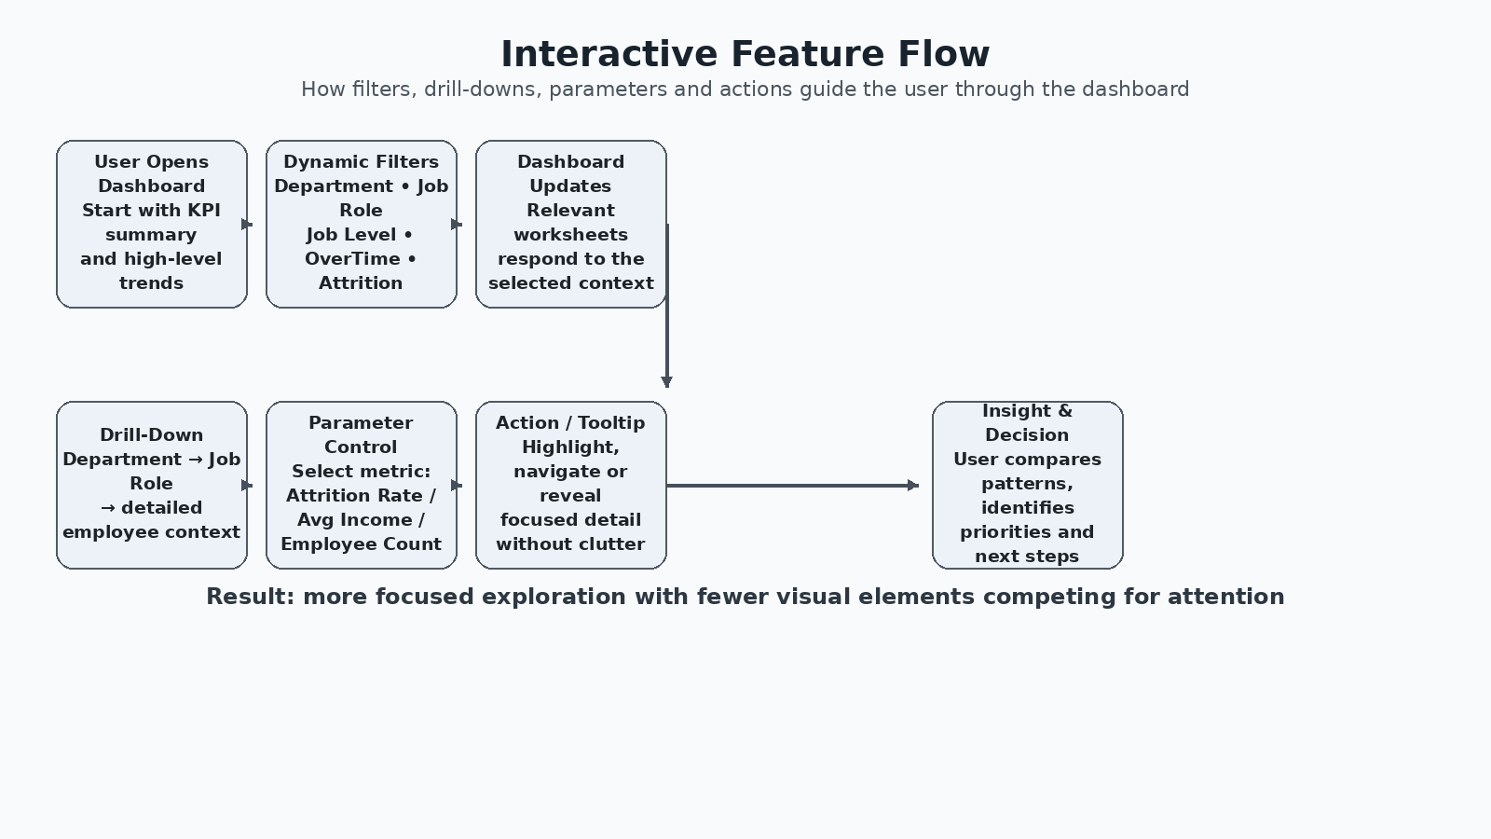

.

9.1 Dynamic Filters
Recommended controls include Department, Job Role, Job Level, OverTime and, where analytically justified, Attrition. Selecting a filter should update the relevant KPI cards and charts together so the user maintains a consistent analytical context.

9.2 Drill-Down Strategy
A practical hierarchy is Department → Job Role → detailed employee context. The first level answers where the pattern occurs; the second explains which roles contribute to it; the detailed view supports investigation without forcing the main dashboard to display employee-level information at all times.

9.3 Parameter Control
A parameter can allow the user to choose the metric being emphasized, such as Attrition Rate, Average Monthly Income or Employee Count. This can reduce the need for separate charts that communicate similar questions.

9.4 Dashboard Actions
- Highlight actions can emphasize related marks across views.
- Filter actions can transfer a user's selection from one chart to another.
- Navigation actions can move users to a detailed analytical sheet without overcrowding the main dashboard.

9.5 Tooltips
Tooltips should reveal useful secondary information only when the user hovers over a mark. This keeps the primary view clean while still supporting deeper exploration.

10. Before vs After Optimization Framework
Area | Before — Risk/Opportunity | After — Proposed Design
Data | Potentially unnecessary fields and detail | Lean, purpose-built data source/extract.
Calculations | Repeated or complex logic | Simplified and documented calculations.
Filters | Many possible controls | Small set of high-value filters.
Visuals | Potentially too many worksheets | Focused analytical views.
Marks | Dense detail may affect rendering | Aggregated where appropriate.
Interaction | Multiple independent controls | Connected, predictable interactions.
User experience | More searching and scrolling | Clear hierarchy and guided exploration.

11. User-Centered Interaction Design
- Start with a high-level KPI and trend view so the user understands the overall attrition context.
- Use a small number of primary filters to narrow the organizational context.
- Allow drill-down from Department to Job Role when the user identifies an area requiring investigation.
- Use a parameter when multiple metrics can be displayed within the same visual structure.
- Use tooltip details and highlight/filter actions for focused exploration.
- Return the user to a clear overview or navigation point after detailed exploration.

12. Implementation Roadmap
Phase | Action | Output
1. Baseline | Review workbook structure and document current/hypothetical risks | Performance assessment checklist
2. Data | Review fields, source design and extract opportunity | Lean data-source strategy
3. Logic | Review calculations and aggregation level | Simplified calculation framework
4. Filters | Select essential controls and remove unnecessary ones | Focused filter panel
5. Design | Reduce worksheets, marks and redundant elements | Cleaner dashboard layout
6. Interactivity | Add filters, drill-down, parameter and actions | Guided interactive workflow
7. Validation | Test functionality and compare perceived responsiveness | Optimization validation notes
8. Documentation | Record changes and expected benefits | Maintainable implementation guide

13. Expected Outcomes
- Improved perceived responsiveness through reduced dashboard workload and clutter.
- Better scalability as the dashboard grows in data volume and user demand.
- More predictable and intuitive interactions.
- Less visual overload through focused charts and tooltips.
- A clearer path from overview → filtering → drill-down → detailed insight.
- A maintainable Tableau design that can be refined after actual performance testing.

14. Evaluation Criteria Alignment
Evaluation Criterion | How This Report Addresses It
Depth of performance analysis/issues | Identifies data, calculations, filters, marks, worksheets, actions and design complexity as potential bottleneck areas.
Practicality/effectiveness of strategies | Provides actionable optimization steps for data, extracts, calculations, filters, visual workload and dashboard structure.
Clarity of interactive enhancements | Defines dynamic filters, drill-down, parameters, dashboard actions and tooltips with a clear user flow.
Thoroughness/organization | Includes assessment, strategy, diagrams, before/after framework, roadmap, outcomes and limitations.
30–35 hour scope | The plan supports structured investigation, implementation, testing, documentation and refinement rather than only adding charts.

15. Limitations and Assumptions
- This is a strategic performance plan based on the assignment's hypothetical-dashboard requirement.
- No actual dashboard load-time, query-duration or rendering benchmark is claimed in this report.
- Specific improvements should be validated in Tableau using the actual workbook, data connection and deployment environment.
- Extracts are recommended where appropriate, not as an unconditional replacement for live connections.
- Income Band thresholds are analytical project groupings and should not be interpreted as official HR compensation grades.
- Interactive controls should be tested for usability after implementation because the optimal number and placement of controls depends on the final dashboard layout.

16. Conclusion
Week 5 transforms the Week 4 analytical dashboard concept into a more performance-conscious and user-centered design strategy. Rather than adding complexity, the recommended approach removes unnecessary workload, prioritizes meaningful calculations and filters, reduces visual density, and introduces interactions that guide users through the analysis.
The most important implementation principle is to validate each optimization with the real Tableau workbook. The proposed workflow therefore ends with testing and monitoring, ensuring that performance improvements are measurable and that interactivity remains intuitive. This creates a practical strategic guide for building a scalable HR attrition dashboard that balances analytical depth, responsiveness and user experience.

